Entrer dans cqlsh :
PS C:\Users\boiss\Desktop\Données distribuées\seance-02\TP_jour2> Set-Location -Path "C:\Users\boiss\Desktop\Données distribuées\seance-02\TP_jour2\TP-OverFast"
PS C:\Users\boiss\Desktop\Données distribuées\seance-02\TP_jour2\TP-OverFast> docker exec -it cassandra cqlsh
________________________________________________
Dans cqlsh
CREATE KEYSPACE IF NOT EXISTS overwatch WITH replication = {'class':'SimpleStrategy','replication_factor':1};

Table créée par Cline
"CREATE TABLE IF NOT EXISTS overwatch.heroes (hero_key text PRIMARY KEY, name text, description text, portrait text, role text, subrole text, location text, age text, birthday text, health int, armor int, shields int, total_hp int, abilities list<text>, backgrounds list<text>, perks_json text, story text, raw_json text, last_update timestamp);"

cqlsh> DESCRIBE KEYSPACES;
overwatch system_auth system_schema system_views
system system_distributed system_traces system_virtual_schema

cqlsh:overwatch> DESCRIBE TABLES;
heroes

cqlsh:overwatch> DESCRIBE TABLE heroes;
CREATE TABLE overwatch.heroes (
hero_key text PRIMARY KEY,
age text,
armor int,
birthday text,
description text,
health int,
last_update timestamp,
location text,
name text,
perks_json text,
portrait text,
raw_json text,
role text,
shields int,
story text,
subrole text,
total_hp int,
abilities list<text>,
backgrounds list<text>
) WITH additional_write_policy = '99p'
AND bloom_filter_fp_chance = 0.01
AND caching = {'keys': 'ALL', 'rows_per_partition': 'NONE'}
AND cdc = false
AND comment = ''
AND compaction = {'class': 'org.apache.cassandra.db.compaction.SizeTieredCompactionStrategy', 'max_threshold': '32', 'min_threshold': '4'}
AND compression = {'chunk_length_in_kb': '16', 'class': 'org.apache.cassandra.io.compress.LZ4Compressor'}
AND memtable = 'default'
AND crc_check_chance = 1.0
AND default_time_to_live = 0
AND extensions = {}
AND gc_grace_seconds = 864000
AND max_index_interval = 2048
AND memtable_flush_period_in_ms = 0
AND min_index_interval = 128
AND read_repair = 'BLOCKING'
AND speculative_retry = '99p';
- Générer et exécuter un script d’ingestion pour peupler overwatch.heroes depuis l’API OverFast.
- Je peux créer un script script/get_overwatch.py qui:
- appelle l’endpoint /heroes (puis détail si nécessaire),
- mappe les champs vers les colonnes (abilities noms, backgrounds urls, hitpoints → health/armor/shields/total_hp),
- insère dans overwatch.heroes,
- journalise le nombre d’insertions.

- Vérifier ensuite:
- docker exec -it cassandra cqlsh -e "SELECT hero_key, name, role FROM overwatch.heroes LIMIT 10;"
- docker exec -it cassandra cqlsh -e "SELECT COUNT(*) FROM overwatch.heroes;"

cqlsh:overwatch> SELECT hero_key, health FROM overwatch.heroes where hero_key='winston' ;
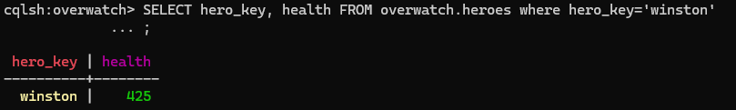
____________________________________________________________________________
-- Mettre les PV (total) de Winston à 10000
-- On place toute la vie dans "health" et on remet armor/shields à 0 pour garder total_hp cohérent
UPDATE overwatch.heroes
SET health = 10000,
armor = 0,
shields = 0,
total_hp = 10000
WHERE hero_key = 'winston';
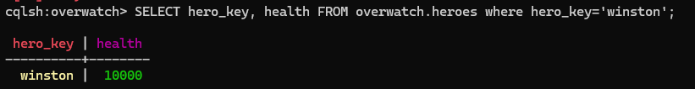
Supprimer winston
-- Supprimer Winston de la table
DELETE FROM overwatch.heroes WHERE hero_key = 'winston';
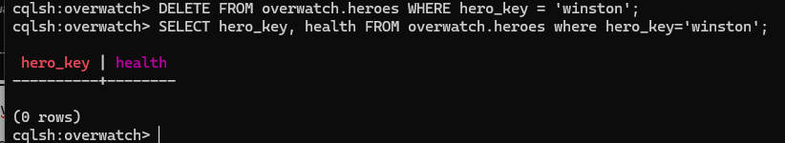
-- Réinsérer Winston avec ses valeurs de base (retour aux données par défaut)
-- Si la ligne existe déjà, vous pouvez au préalable exécuter DELETE (voir 02_delete_winston.sql)

INSERT INTO overwatch.heroes (
hero_key, name, description, portrait, role, subrole, location, age, birthday,
health, armor, shields, total_hp, abilities, backgrounds, perks_json, story, raw_json, last_update
) VALUES (
'winston',
'Winston',
'A super-intelligent, genetically engineered gorilla, Winston is a brilliant scientist and a champion for humanity’s potential.',
'https://d15f34w2p8l1cc.cloudfront.net/overwatch/46a10db3aa908c590ddc4e7606376a88143d1f1306ecfbea043263040f9529a5.png',
'tank',
'initiator',
'Horizon Lunar Colony (formerly), Watchpoint: Gibraltar',
'31',
'Jun 6',
425,
200,
0,
625,
[ 'Tesla Cannon', 'Jump Pack', 'Barrier Projector', 'Primal Rage' ],
[
'https://blz-contentstack-images.akamaized.net/v3/assets/blt2477dcaf4ebd440c/blt393ab319cd413b01/638810d775e4d50e88ea3b30/winston-00.jpg',
'https://blz-contentstack-images.akamaized.net/v3/assets/blt2477dcaf4ebd440c/blt8b22e773484e0ecf/638810d73ae72d1147f2401a/winston-01.jpg'
],
'{}',
null,
null,
toTimestamp(now())
);
Copier les fichiers .sql dans le docker :
mkdir -Force C:\temp\noop > $null; `docker exec cassandra mkdir -p /queries;` docker cp "C:\Users\boiss\Desktop\Données distribuées\seance-02\TP_jour2\queries\01_update_winston.sql" cassandra:/queries/01_update_winston.sql; `docker cp "C:\Users\boiss\Desktop\Données distribuées\seance-02\TP_jour2\queries\02_delete_winston.sql" cassandra:/queries/02_delete_winston.sql;` docker cp "C:\Users\boiss\Desktop\Données distribuées\seance-02\TP_jour2\queries\03_reinsert_winston_defaults.sql" cassandra:/queries/03_reinsert_winston_defaults.sql; `docker exec cassandra ls -l /queries || true;` docker exec cassandra cqlsh -f /queries/01_update_winston.sql; ` docker exec cassandra cqlsh -e "SELECT health, armor, shields, total_hp FROM overwatch.heroes WHERE hero_key='winston';"
_____________________________________________________________________________
(SOURCE '/ 03_reinsert_winston_defaults.sql’; ) -> ne fonctionne pas car dossier non créé/reconnu dans docker mais fuck
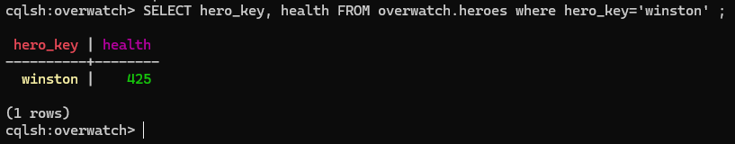

SELECT *FROM overwatch.heroes where hero_key='reinhardt' ;

Les requêtes à créer : exemple :
CREATE TABLE orders (
customer_id text,
order_data timestamp,
product text,
amount decimal,
PRIMARY KEY ((customer_id), order_date)
);

Colonnes à garder pour les requêtes :

